**MODEL META DATA**

**Model Name:** u-net-1000images-baseline

**Architecture:** U-Net

**Numpy or Image Generator:** Numpy

**Epochs:** 10

**Batch size:** 8

**Learning rate:** 0.01

**No of images:** 1008

**Performance Metrics:** IOU, Accuracy

**Colab or Kaggle:** Colab

**Filename:** Basic U-Net

**Results:** IOU - 18.06, Accuracy - 95.81

**Comments:** Scaling done by directly dividing by 255

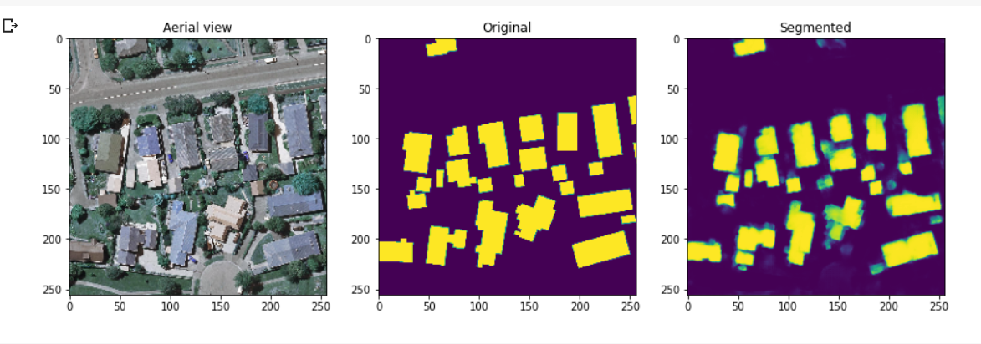

**Model Name:** unet-youtube-1000images-10epochs

**Architecture:** U-Net

**Numpy or Image Generator:** Numpy

**Epochs:** 10

**Batch size:** 16

**Learning rate:** 0.01

**No of images:** 1008

**Performance Metrics:** IOU, Dice Coefficient, Accuracy

**Colab or Kaggle:** Colab

**Filename:** Youtube U-Net

**Results:** IOU - 64.73, Dice Coefficient - 78.43 Accuracy - 94.84

**Comments:** Used MinMaxScaler, Referred Digital Sreeni video

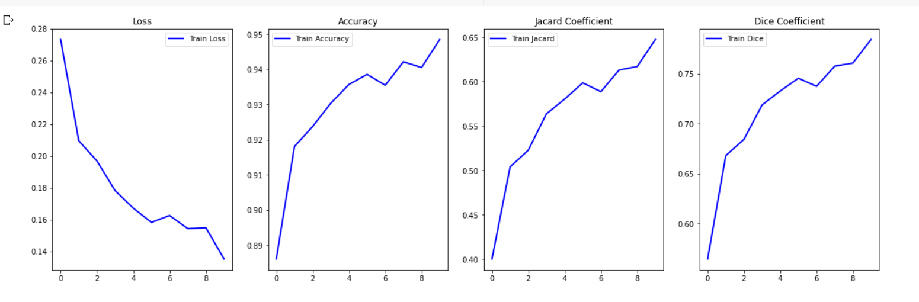

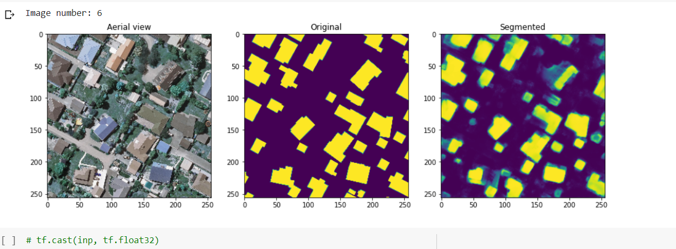

**Model Name:** unetmcc-youtube-1000images-10epochs

**Architecture:** U-Net

**Numpy or Image Generator:** Numpy

**Epochs:** 10

**Batch size:** 16

**Learning rate:** 0.01

**No of images:** 1008

**Performance Metrics:** IOU, Dice Coefficient, MCC, Accuracy

**Colab or Kaggle:** Colab

**Filename:** Youtube U-Net

**Results:** IOU - 68.22, Dice Coefficient - 80.99, MCC - 14.40, Accuracy - 95.37

**Comments:** Used MinMaxScaler, Added MCC also as performance metrics, Referred Digital Sreeni video

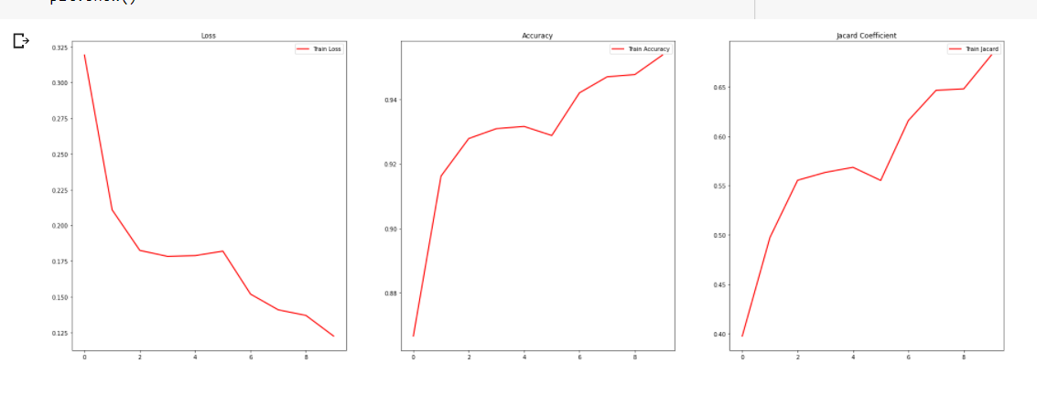

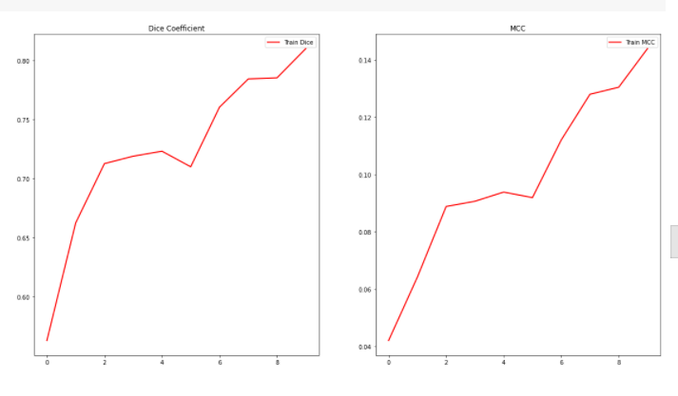

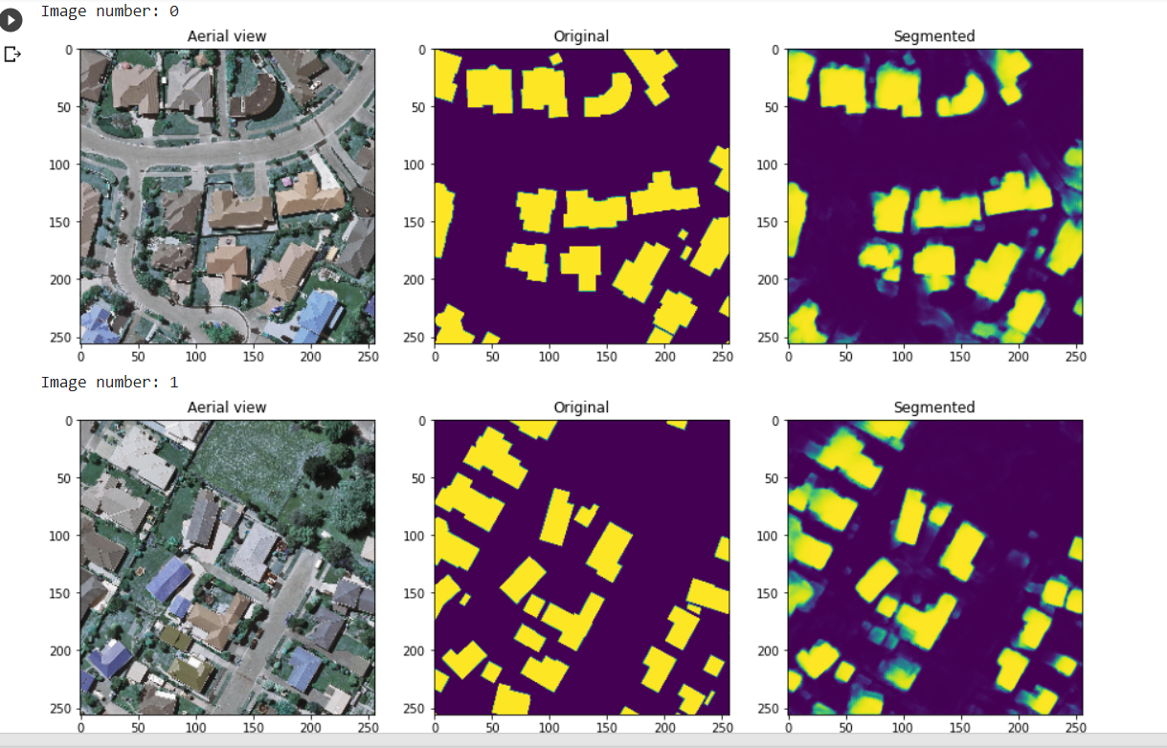

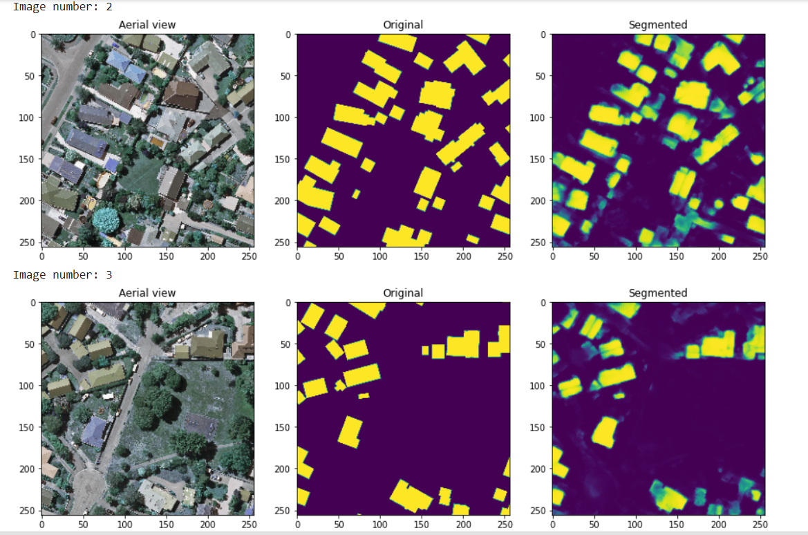

**Model Name:** resumable-model

**Architecture:** U-Net

**Numpy or Image Generator:** Numpy

**Epochs:** 15

**Batch size:** 8

**Learning rate:** 0.001

**No of images:** 1008

**Performance Metrics:** IOU, Dice Coefficient, MCC, Accuracy

**Colab or Kaggle:** Colab

**Filename:** Youtube U-Net

**Results:** IOU - 70.36, Dice Coefficient - 82.34, MCC - NaN, Accuracy - 94.98

**Comments:** Same as above, Tried How to start, stop resume training of a model using keras-buoy

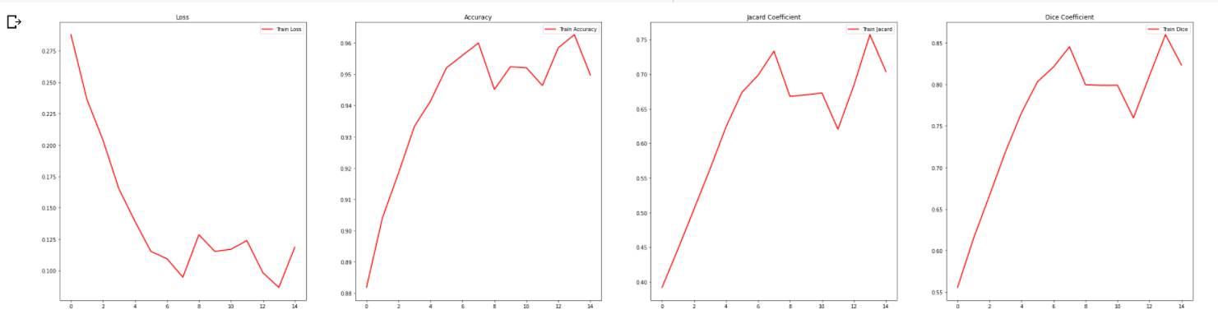

**Model Name:** 1500images-30epochs

**Architecture:** MultiRes U-Net

**Numpy or Image Generator:** Numpy

**Epochs:** 30

**Batch size:** 8

**Learning rate:** 0.0001

**No of images:** 1548

**Performance Metrics:** IOU, Dice Coefficient, MCC, Accuracy

**Colab or Kaggle:** Kaggle

**Filename:** 1500 Numpy MultiRes Version 1 - Numpy MultiRes, U-Net

**Results:** IOU - 30.21, Dice Coefficient - 45.87, MCC - 0.89, Accuracy - 97.53, Loss - 0.3288

**Comments:** Tried MultiRes U-Net with numpy array.

**Model Name:** 1500images-npy-100epochs

**Architecture:** U-Net

**Numpy or Image Generator:** Numpy

**Epochs:** 100

**Batch size:** 8

**Learning rate:** 0.0001

**No of images:** 1548

**Performance Metrics:** IOU, Dice Coefficient, MCC, Accuracy

**Colab or Kaggle:** Kaggle

**Filename:** 1500 Numpy MultiRes Version 1 - Numpy MultiRes, U-Net

**Results:** IOU - 86.81, Dice Coefficient - 92.83, MCC - 48.97, Accuracy - 98.28, Loss - 0.0339

**Comments:** U-Net with numpy array. Ran faster than in Colab. Took 48s for each epoch in Kaggle compared to 2mins in Colab.

**Model Name:** focalloss-30epochs

**Architecture:** MultiRes U-Net

**Numpy or Image Generator:** Numpy

**Epochs:** 100

**Batch size:** 8

**Learning rate:** 0.0001

**No of images:** 1008

**Performance Metrics:** IOU, Dice Coefficient, MCC, Accuracy

**Colab or Kaggle:** Kaggle

**Filename:** Keras Data Generator Version 1 - multires-30

**Results:** IOU - 32.33, Dice Coefficient - 48.43, MCC - 0.88, Accuracy - 97.73, Loss - 0.0422

**Comments:** MultiRes with binary focal loss instead of binary cross entropy loss.

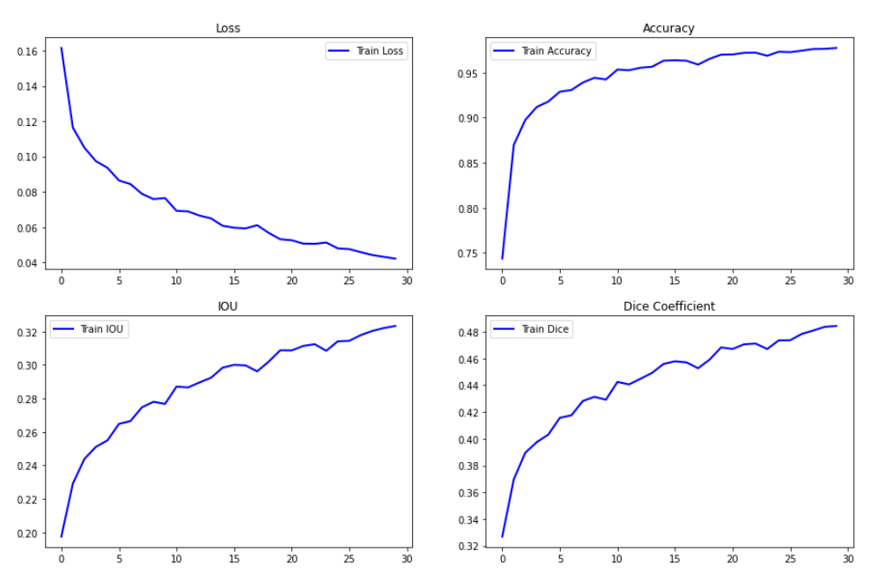

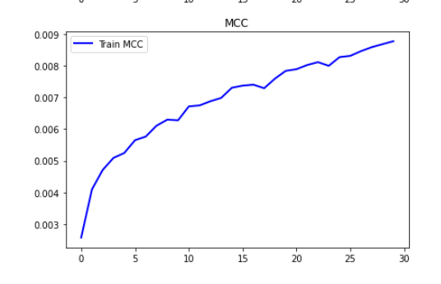

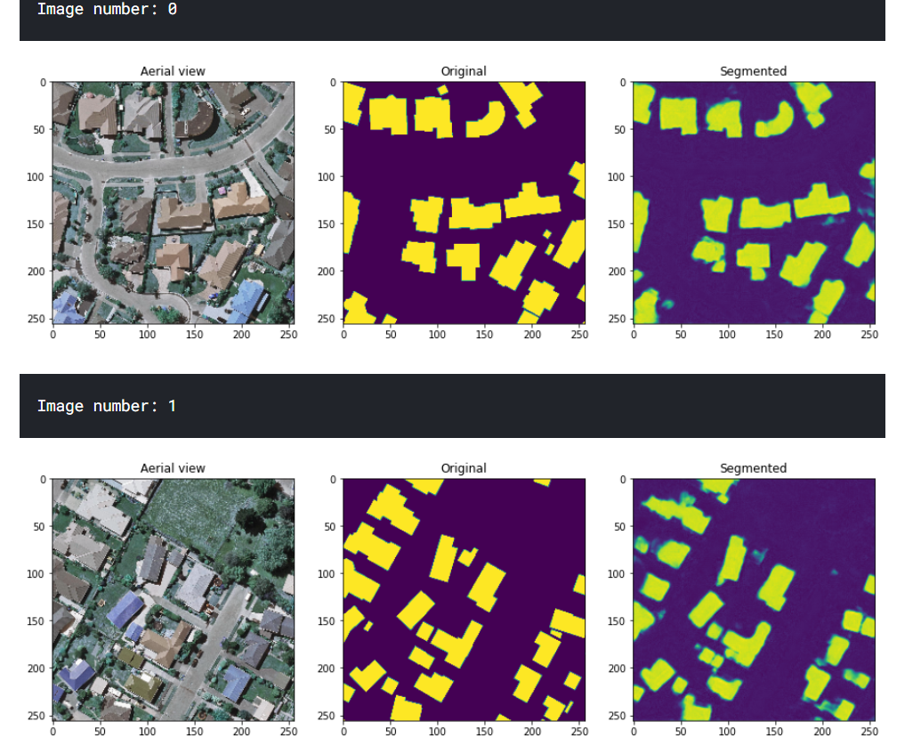

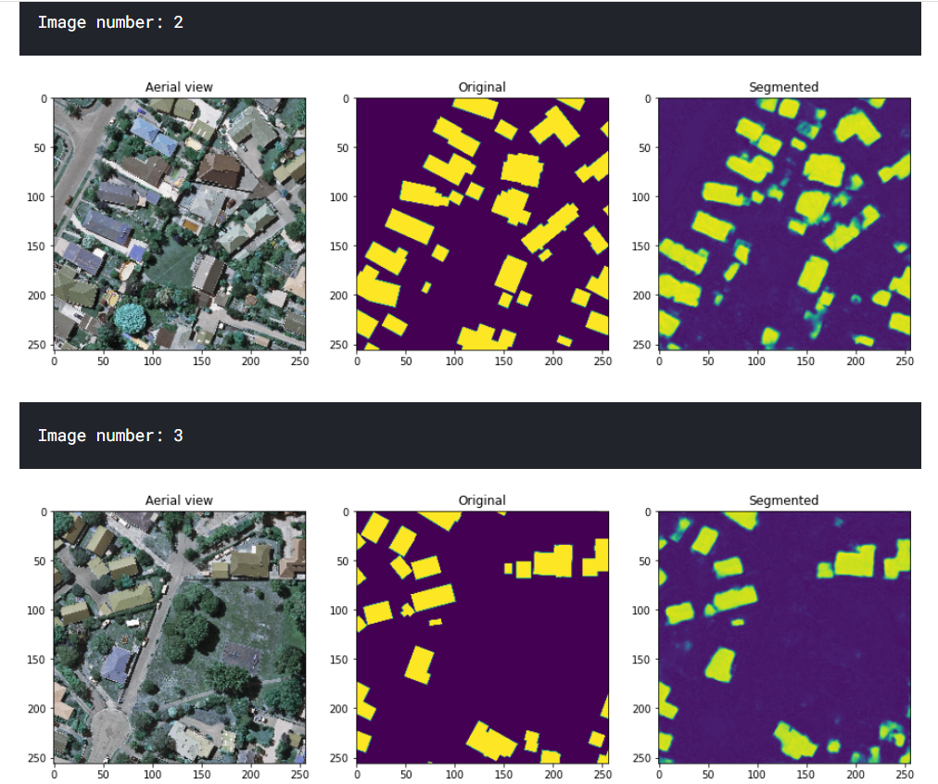

**Model Name:** MultiRes-100epochs-lr1e-4

**Architecture:** MultiRes U-Net

**Numpy or Image Generator:** Numpy

**Epochs:** 100

**Batch size:** 16

**Learning rate:** 0.0001

**No of images:** 1008

**Performance Metrics:** IOU, Dice Coefficient, MCC, Accuracy

**Colab or Kaggle:** Kaggle

**Filename:** Keras Data Generator Version 1 - multires-30

**Results:** IOU - 35.18, Dice Coefficient - 51.91, MCC - 1.66, Accuracy - 97.51, Loss - 0.3047

**Comments:** IOU with MultiRes doesn't increase after 35% even with 100 epochs for different learning rates as well. For learning rate = 0.01, IOU at end of 100 epochs is 38.93%.

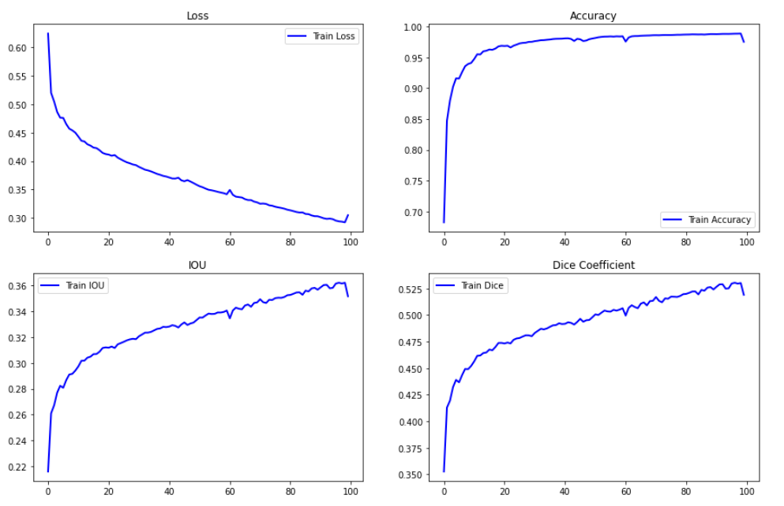

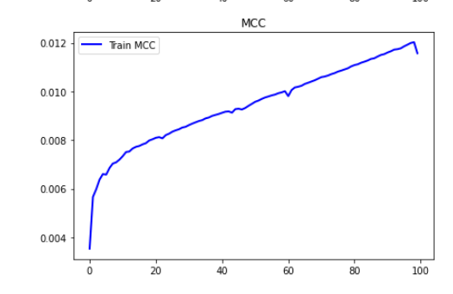

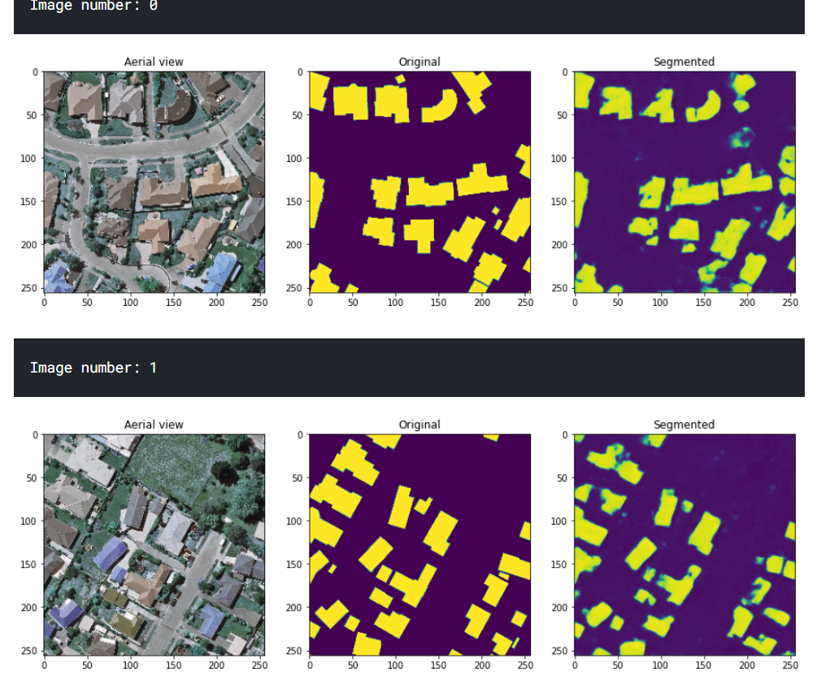

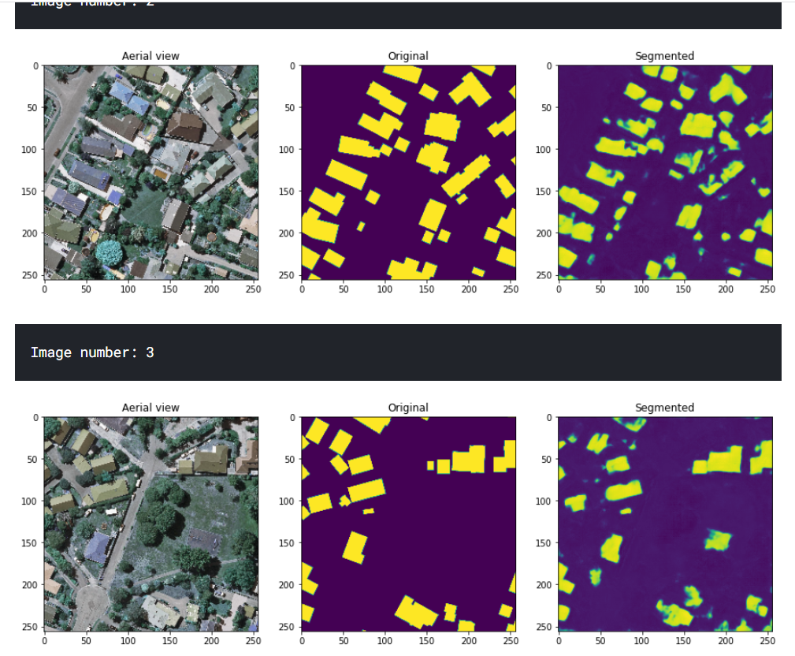

**Model Name:** unet2-1000images-100epochs

**Architecture:** U-Net

**Numpy or Image Generator:** Numpy

**Epochs:** 100

**Batch size:** 8

**Learning rate:** 0.0001

**No of images:** 1008

**Performance Metrics:** IOU, Dice Coefficient, MCC, Accuracy

**Colab or Kaggle:** Colab

**Filename:** U-Net Final

**Results:** IOU - 88.40, Dice Coefficient - 93.79, MCC – 51.68, Accuracy – 98.22, Loss – 0.0356

**Comments:** Tried resumable models too but that wasn't done properly.

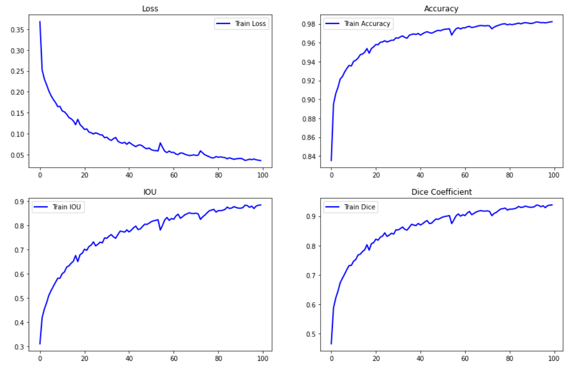

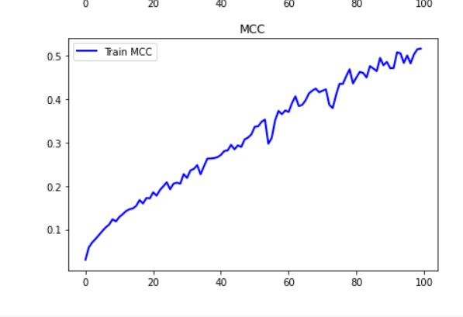

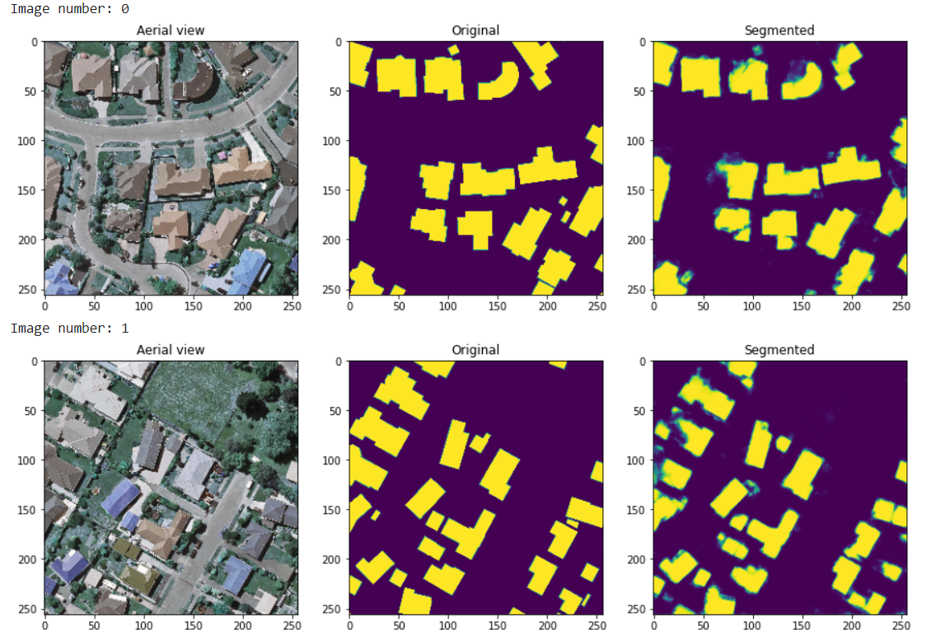

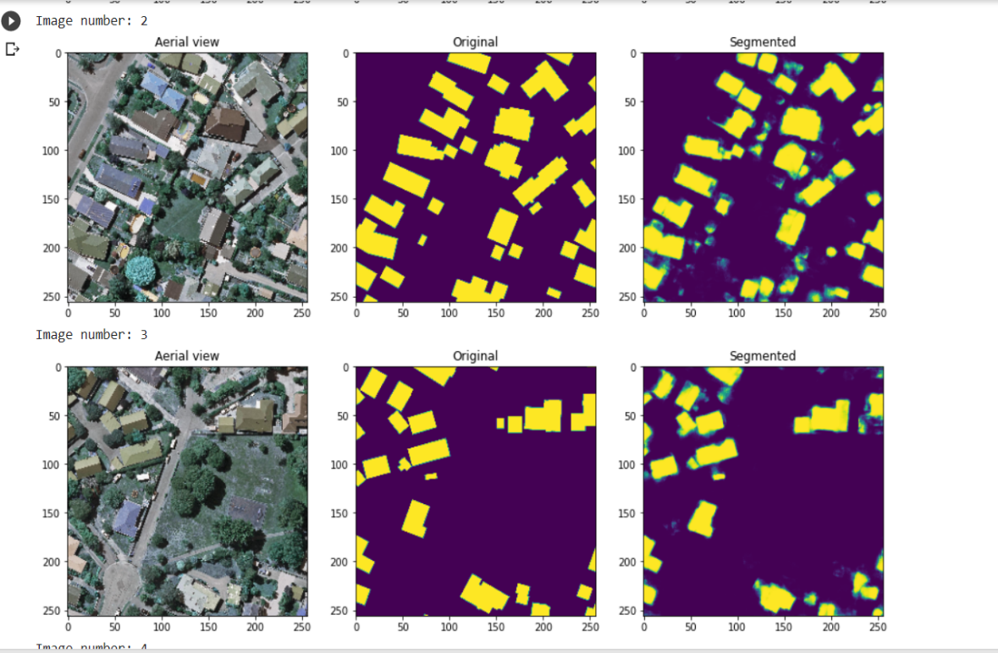

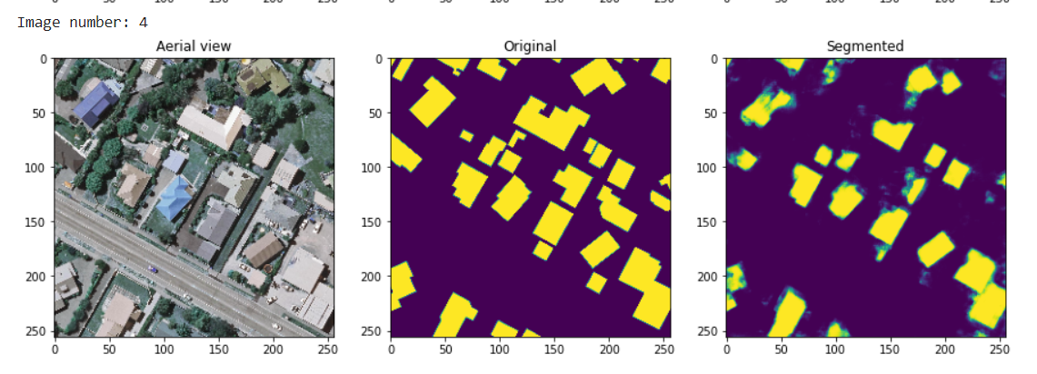

**Model Name:** unet2-1000images-130epochs

**Architecture:** U-Net

**Numpy or Image Generator:** Numpy

**Epochs:** 30 (Continue training from the previous model) 100+30=130

**Batch size:** 8

**Learning rate:** 0.00001

**No of images:** 1008

**Performance Metrics:** IOU, Dice Coefficient, MCC, Accuracy

**Colab or Kaggle:** Colab

**Filename:** U-Net Final

**Results:** IOU - 90.57, Dice Coefficient - 95.02, MCC - 56.88, Accuracy - 98.48, Loss - 0.0279

**Comments:** Continued training from the previous model by loading the weights and decreasing the learning rate. Trained for 30 more epochs.

